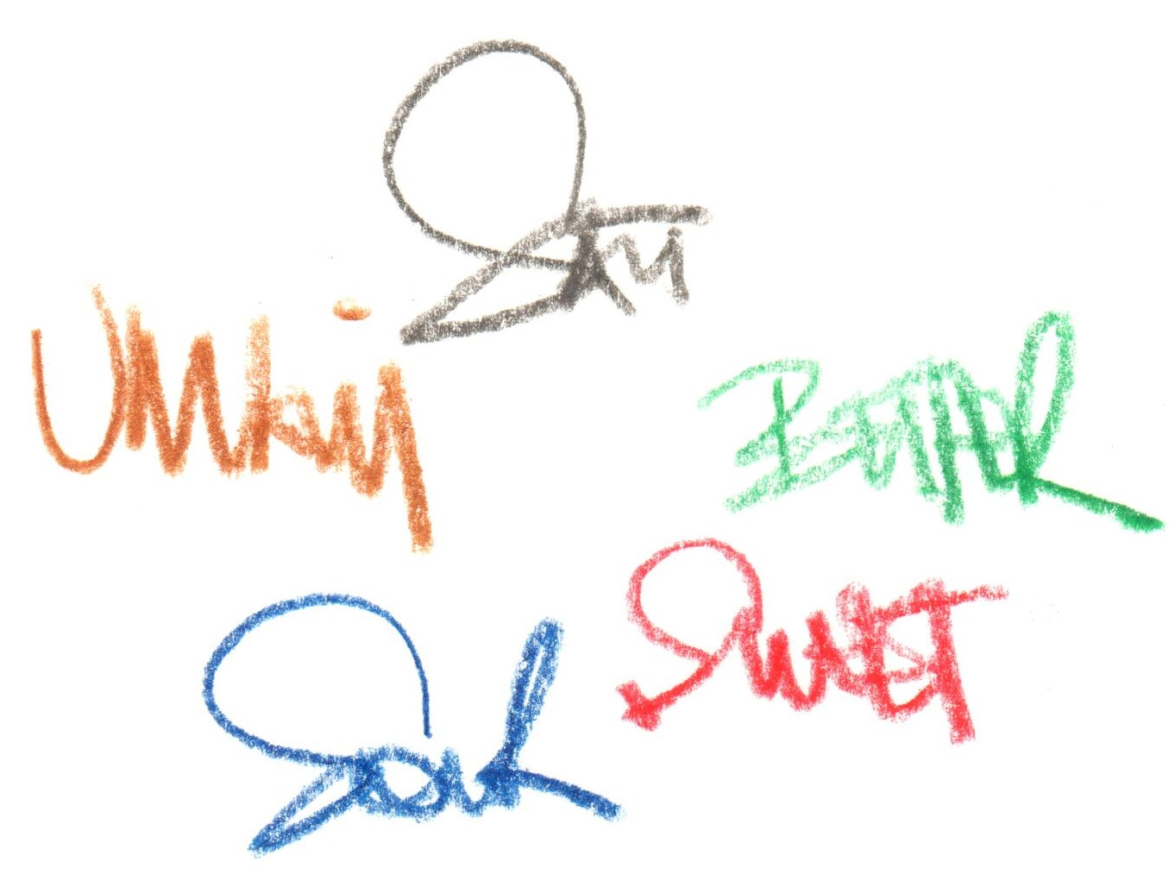

**Introduction**

**“the 5 tastes”**



**Scallop**

**tomato / XO**

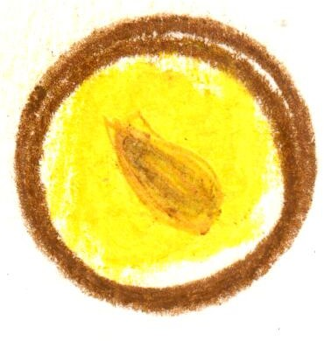

**Crab**

**chawanmushi**

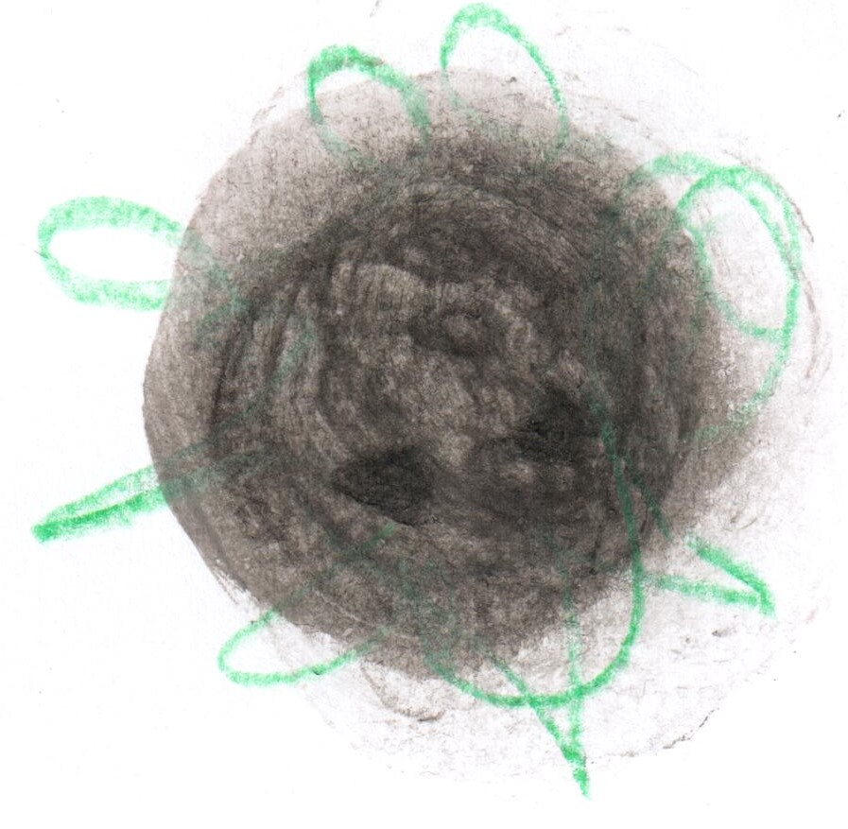

**Potato**

**Oscietra caviar / ash**

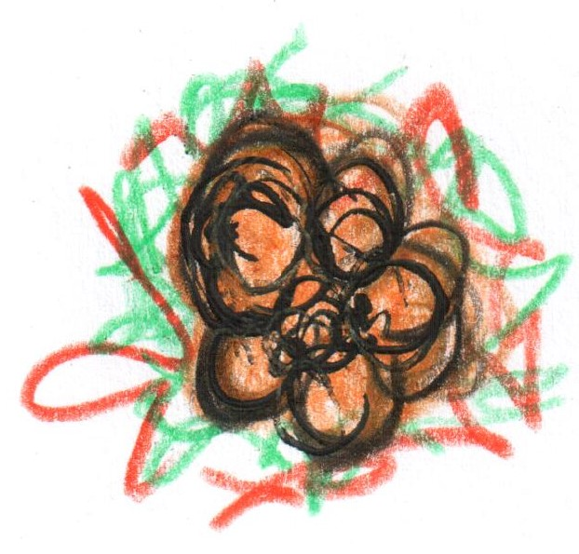

**Veal sweetbread**

**celeriac**

**Sauce Robert**

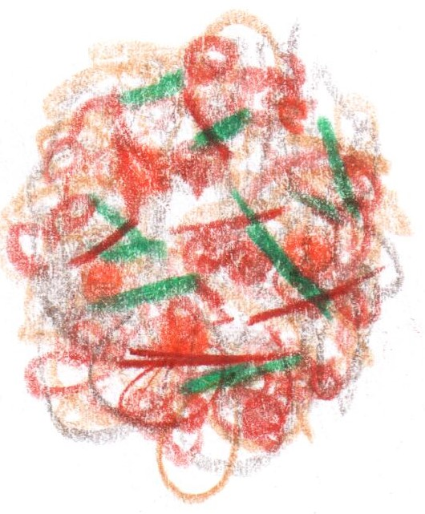

**Muesli**

**RSB Archive**

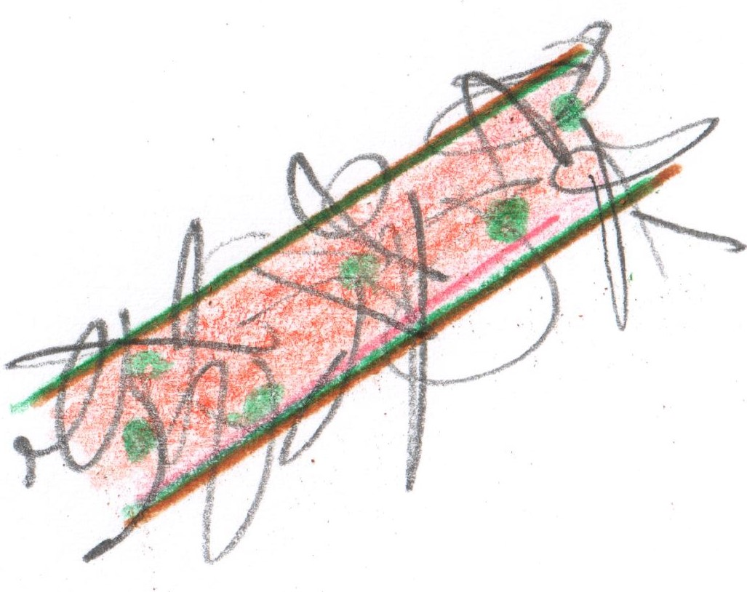

**Salmon**

**“Maki Roll”**

**Venison**

**‘Cannelloni’ of Roots**

**2016 Parmesan**

**Conclusion**

**‘Pelargonium’**



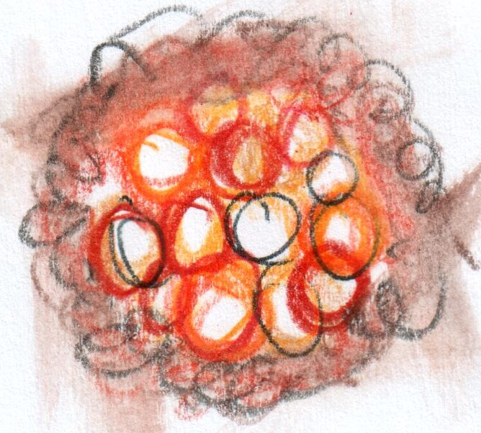



**Dover Sole**

**Autumn truffle / turnip**

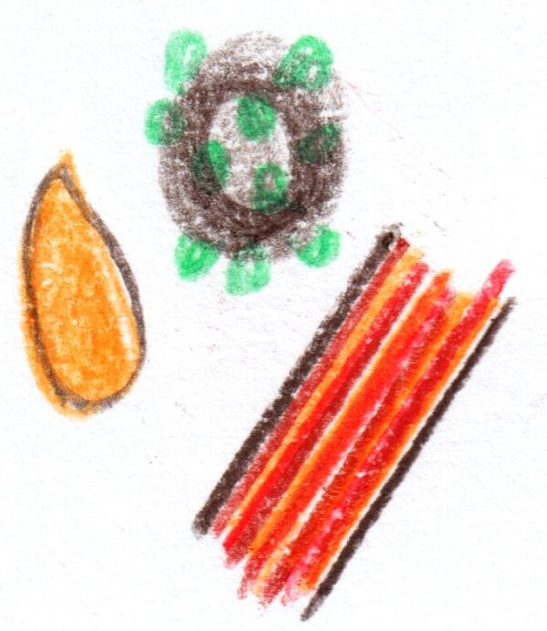

**Wyndford Wagyu**

**“Au Poivre”**

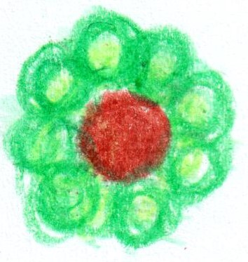

**‘Cheese souffle’**

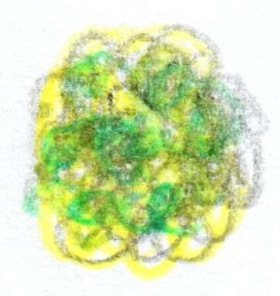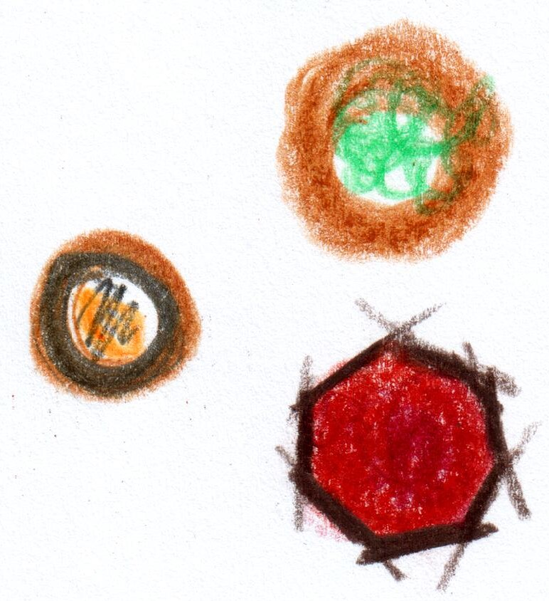

**Conclusion**

**The Garden @ RSB**

**Chocolate Tart**

**à la minute**

**Fifteen Courses**

**£275**

**‘The crossover’**