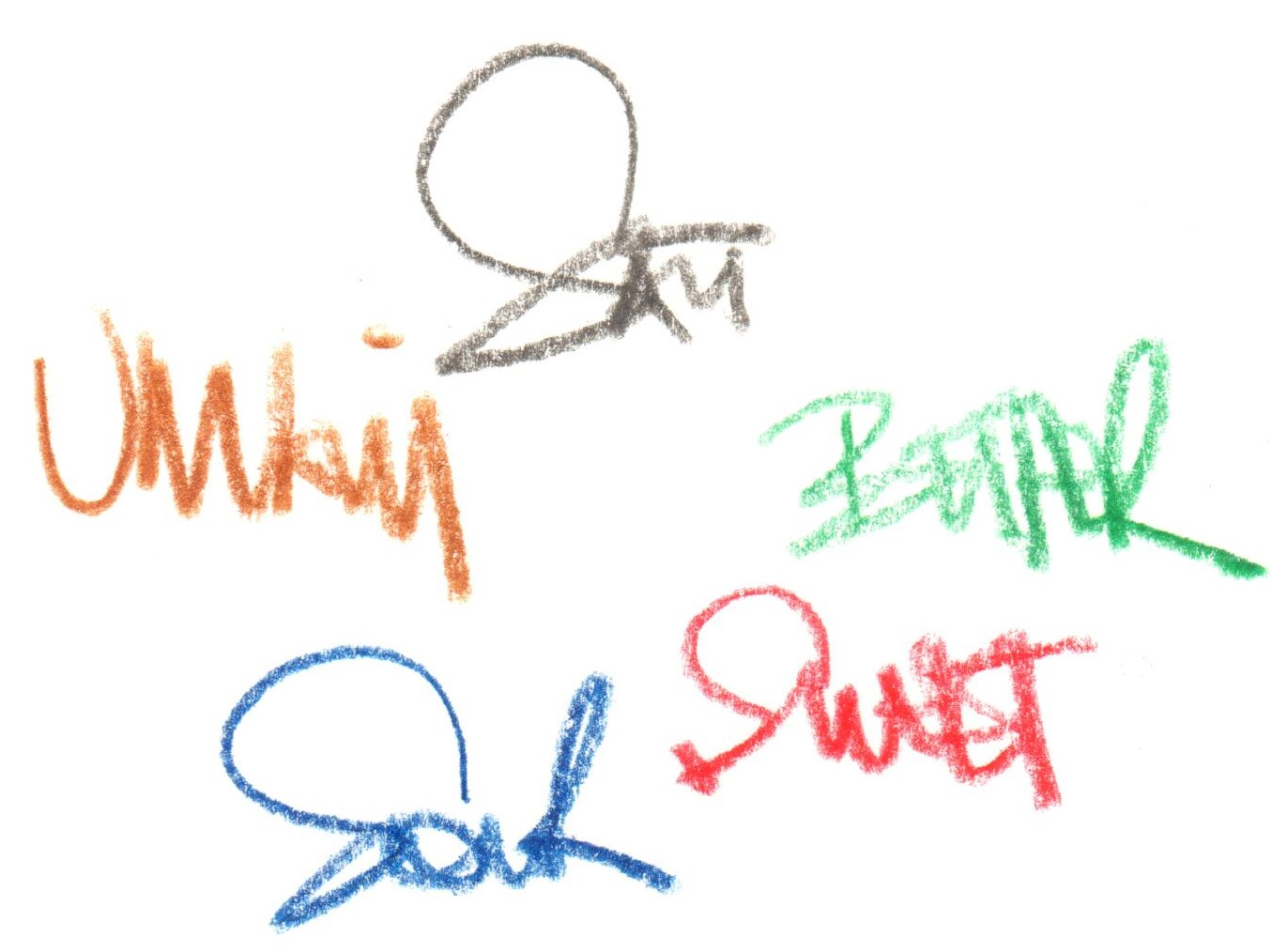

**Introduction**

**“the 5 tastes”**

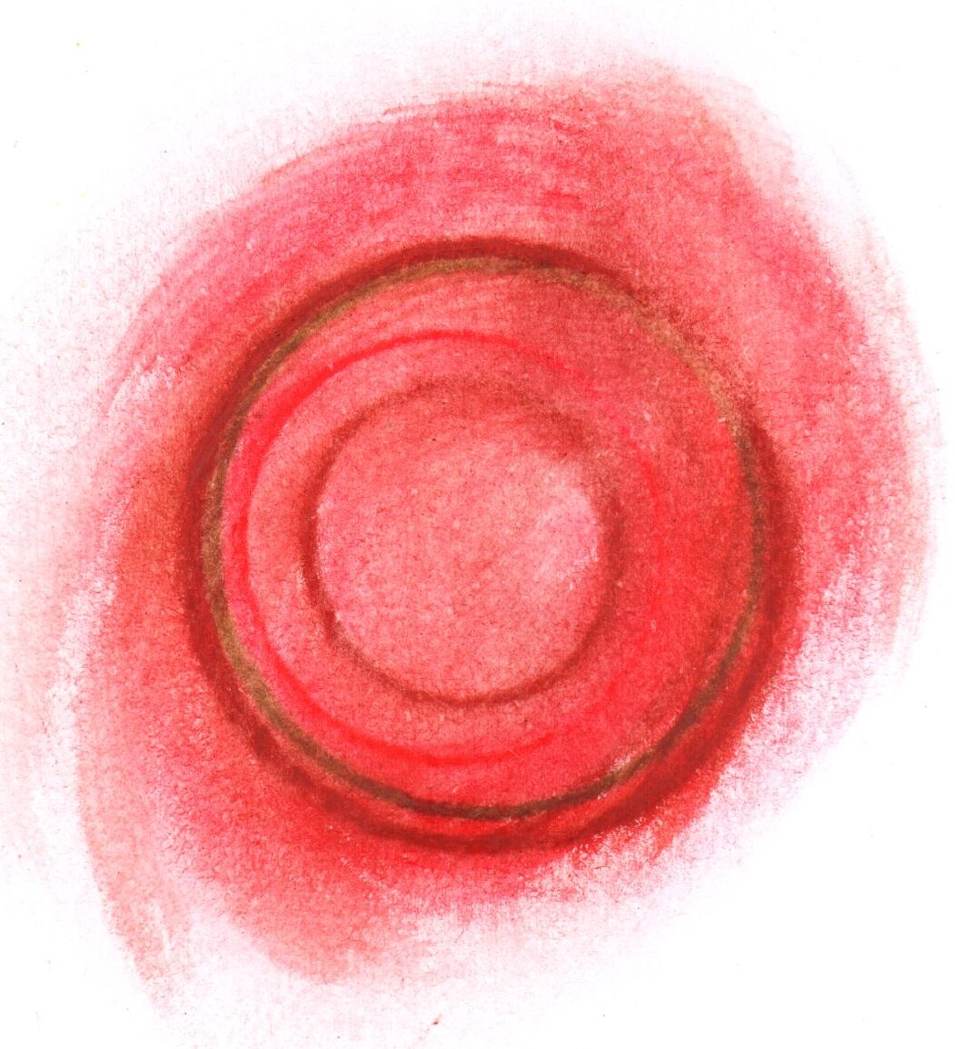

**Scallop**

**tomato / rose**

**truffle**

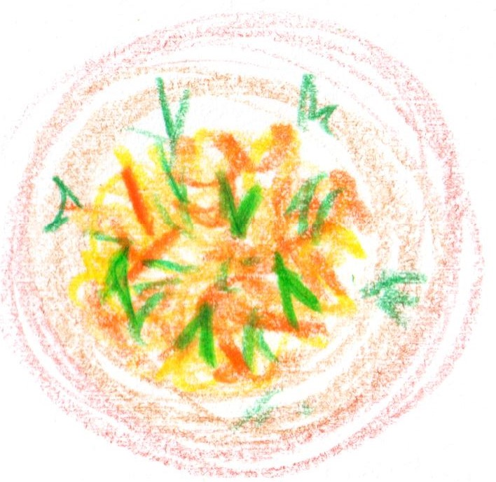

**Cornish Crab**

**white balsamic**

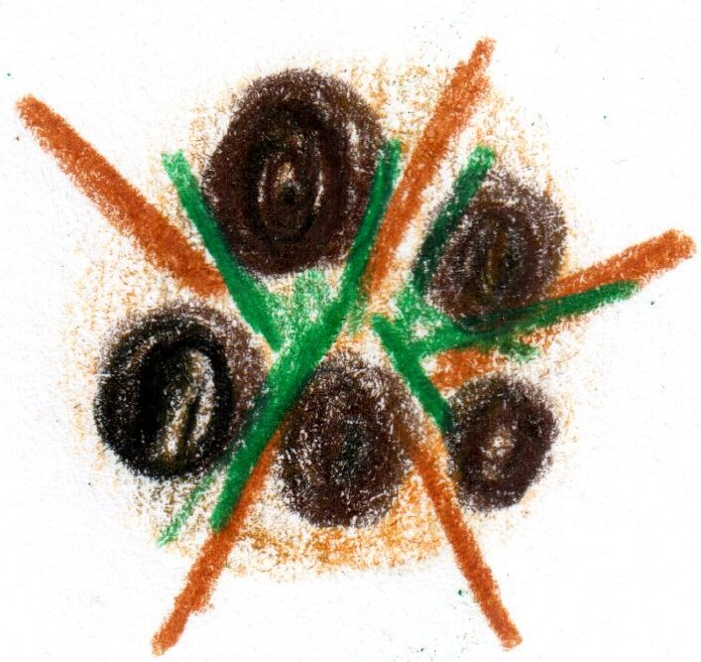

**From the Embers**

**potato / goats cheese**

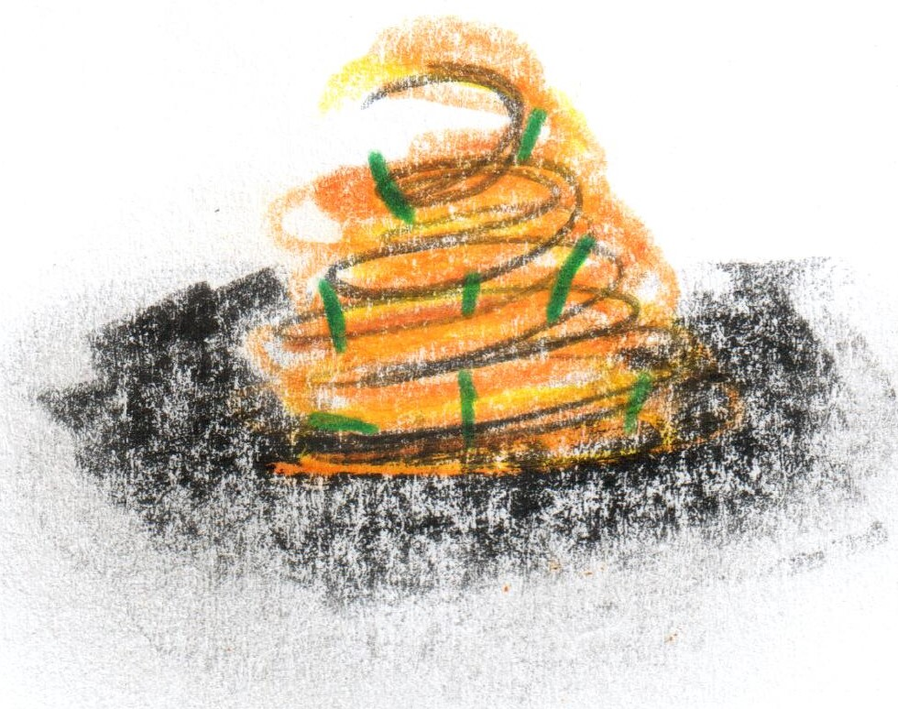

**Veal sweetbread**

**spring cabbage / truffle**

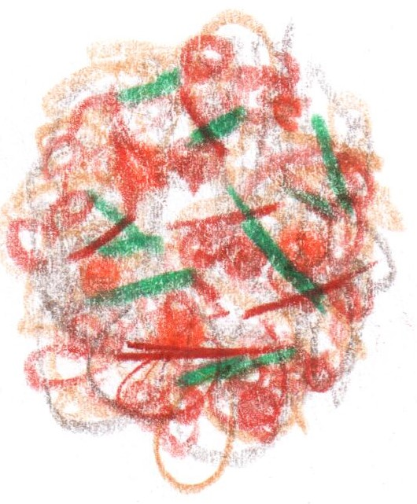

**Muesli**

**RSB Archive**

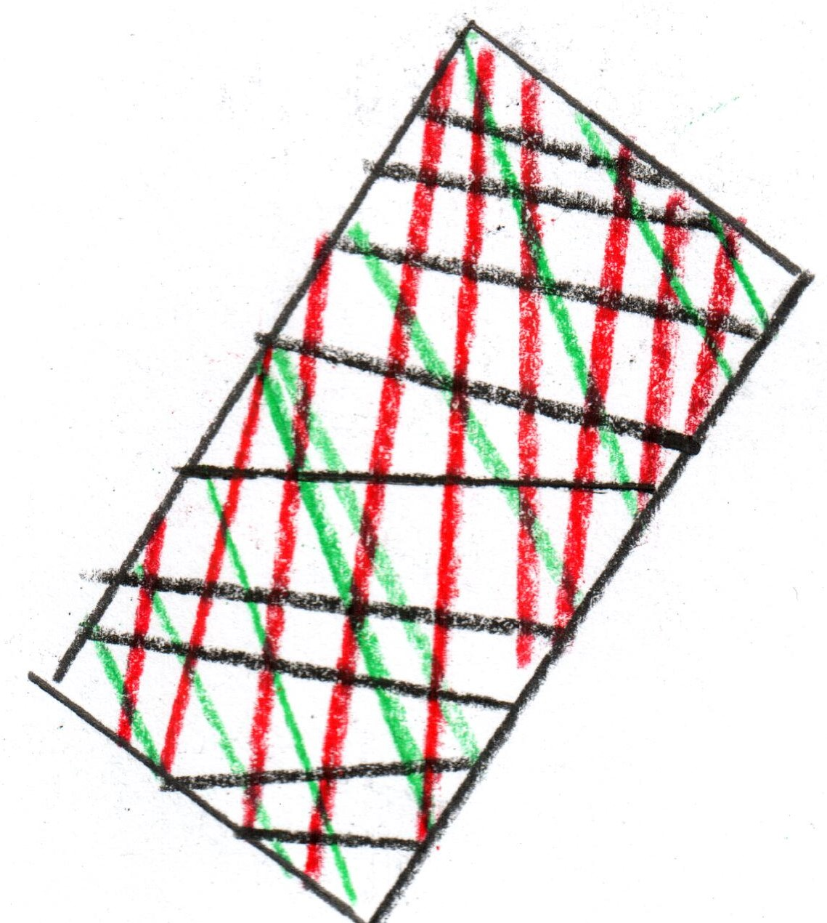

**Salmon “XO”**

**Quiche**

**Morel / wild garlic**

**aged Parmesan**

**Conclusion**

**‘Pelargonium’**

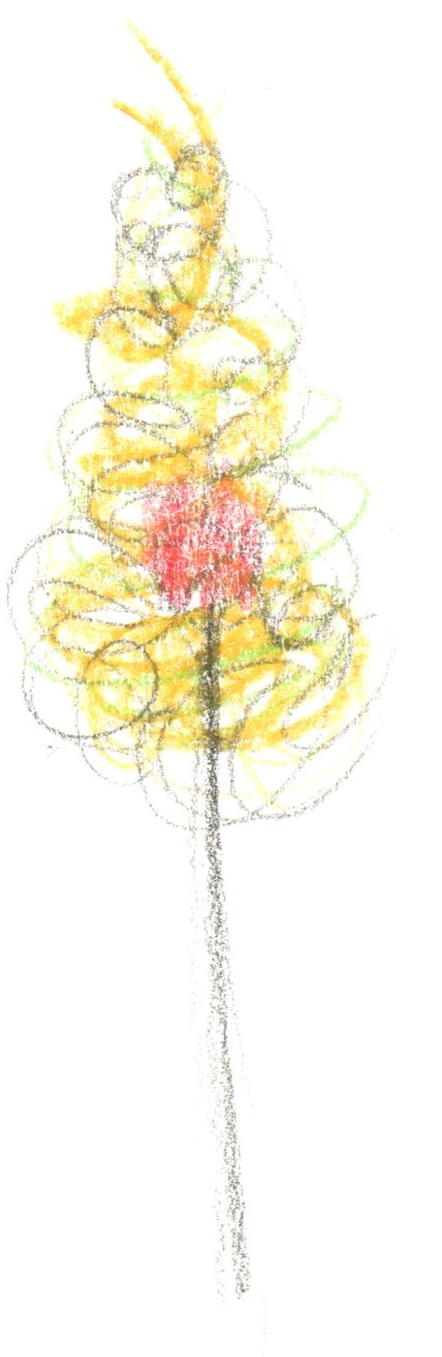

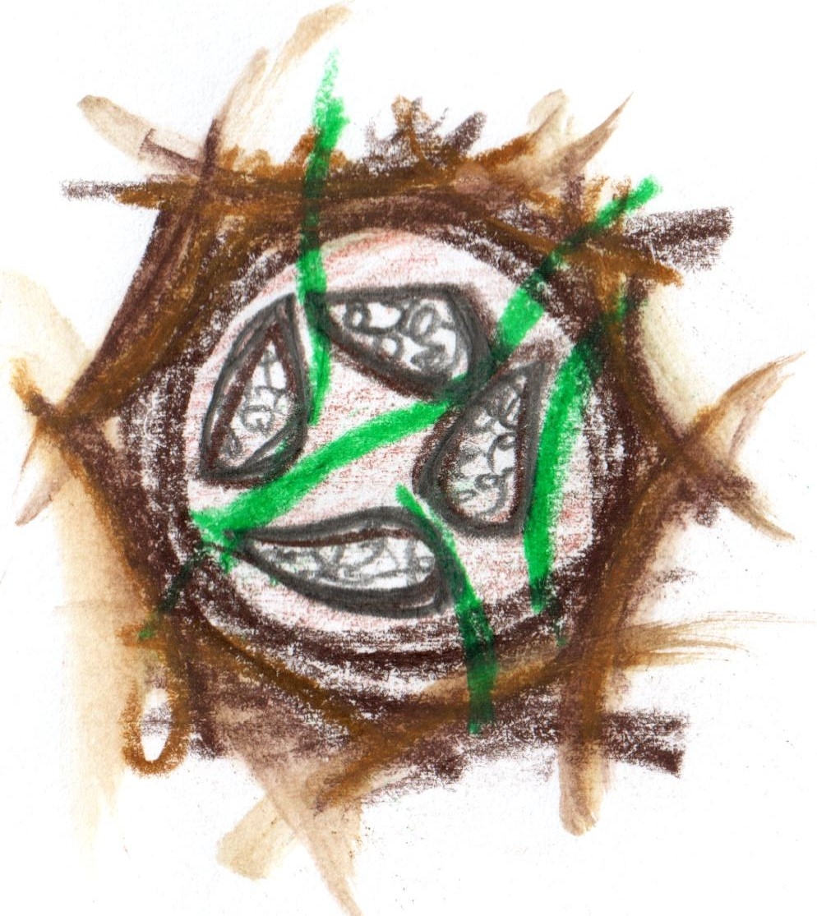

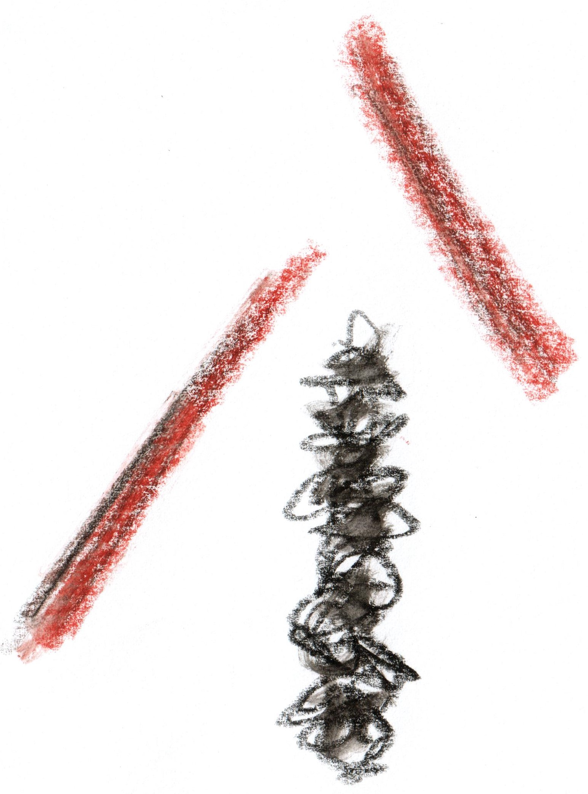

**Turbot Farci**

**salsify / truffle**

**champagne**

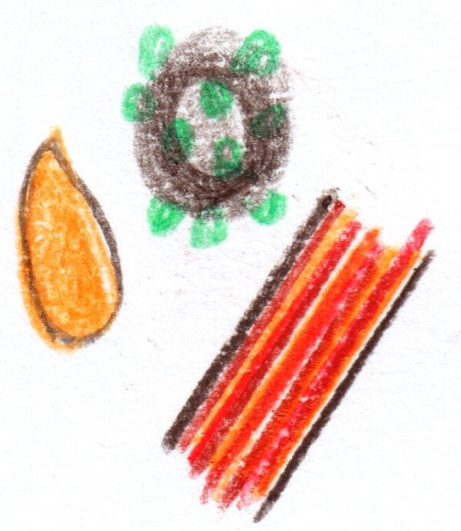

**Wyndford Wagyu**

**‘au poivre’**

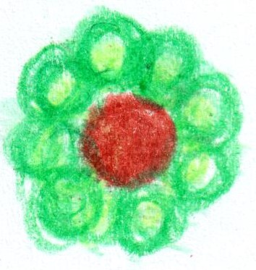

**‘Cheese souffle’**

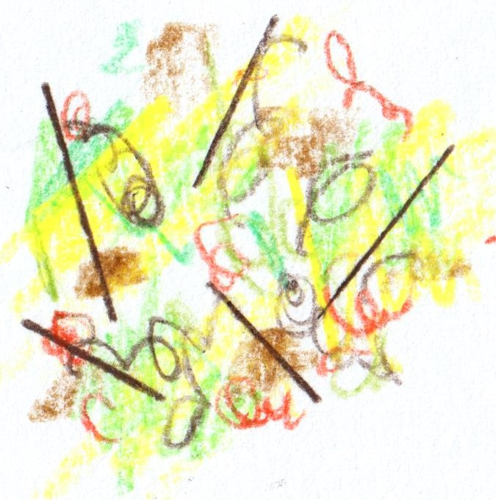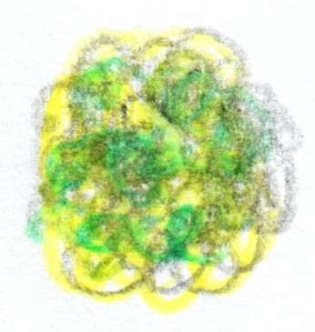

**Rhubarb & Custard**

**Conclusion**

**White Chocolate**

**pine / yuzu**

**Fifteen Courses**

**£279**

**‘The crossover’**